Wide Area Networks

1. How Your Phone Connects to Instagram
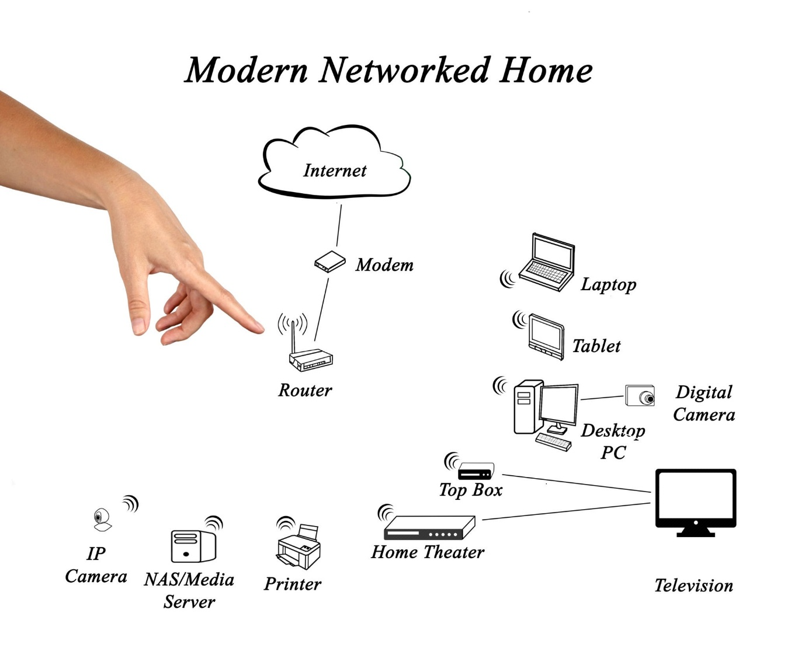

2. Comparison of 3 WAN Technologies :
WAN Type | Speed | Cost | Real-Life Example
Broadband Internet (Home Fiber / Cable) | Fast for normal use, but download speed is usually faster than upload. | Low (Cheap monthly bill). | Your Home: Great for family streaming, everyday browsing, and online gaming.
Leased Line (Dedicated Fiber Cable) | Extremely fast and guaranteed. Upload and download speeds are equal. | Very High (Very expensive custom setup). | IRCTC Ticket Office: Needs 100% reliable connection every second so ticket bookings never crash.
MPLS (Private Managed Network) | Fast, reliable, and smooth. Automatically gives priority to important data. | High (Expensive business package). | Zomato Offices: Connects different city branches so voice calls and live order tracking stay smooth.

3. How a VPN Keeps You Safe on Coffee Shop Wi-Fi :
Public Wi-Fi at a coffee shop is like talking loudly in a crowded room—anyone sitting nearby can eavesdrop on your internet activity.
A VPN (Virtual Private Network) protects you by acting like a secret locked pipe inside a public highway:
- Step 1: Scrambling Your Data: Before your phone sends your Spotify or YouTube search, the VPN app turns it into an unreadable secret code (encryption).
- Step 2: The Secret Tunnel: It puts that code inside a protective package and sends it through the coffee shop Wi-Fi and public internet. Anyone trying to spy on the public network only sees useless scrambled numbers.
- Step 3: The VPN Server: The package travels to a secure VPN server far away. The server unlocks the code, fetches your song from Spotify or video from YouTube, scrambles the answer back up, and sends it safely back to your phone.
4. Best Network Option for Flipkart Warehouses :
To connect warehouses in Ahmedabad, Mumbai, and Delhi, Flipkart should choose MPLS.
Here are two simple reasons why:
- It Is Private and Secure: MPLS acts like a private private road between the warehouses. Customer addresses, inventory lists, and billing data never travel over the open, risky public internet, keeping hackers away.
- It Never Slows Down Important Work: MPLS provides a "VIP fast lane" for critical business operations. Even if heavy files are being transferred, live warehouse updates and order tracking won't freeze or lag.

